# Test Log

Test plan

Test Date: 13.01.2025

|  |  |  |
| --- | --- | --- |
| Test No | Action / Code | Expected |
| TC++001 |  | The program must correctly report an empty map after program initialisation. |
| TC++002 |  | The program must correctly add the following Employee/phone number pairs and correctly display them |
| TC++003 |  | The program must produce the correct response when asked for the phone number of David D. |
| TC++004 |  | The program must produce the correct response when asked for the phone number of Samantha S. |
| TC++005 |  | The program should remove David D. from the directory, and correctly display the updated status of the system. |
| TC++006 |  | The system must correctly add the following Employee/phone number pairs and correctly display them.  Rio N. 1024  Kody U. 6019  Gabriela V. 7029  Felix Q. 4092 |
| TC++007 |  | Remove all of the data from the system and display. |

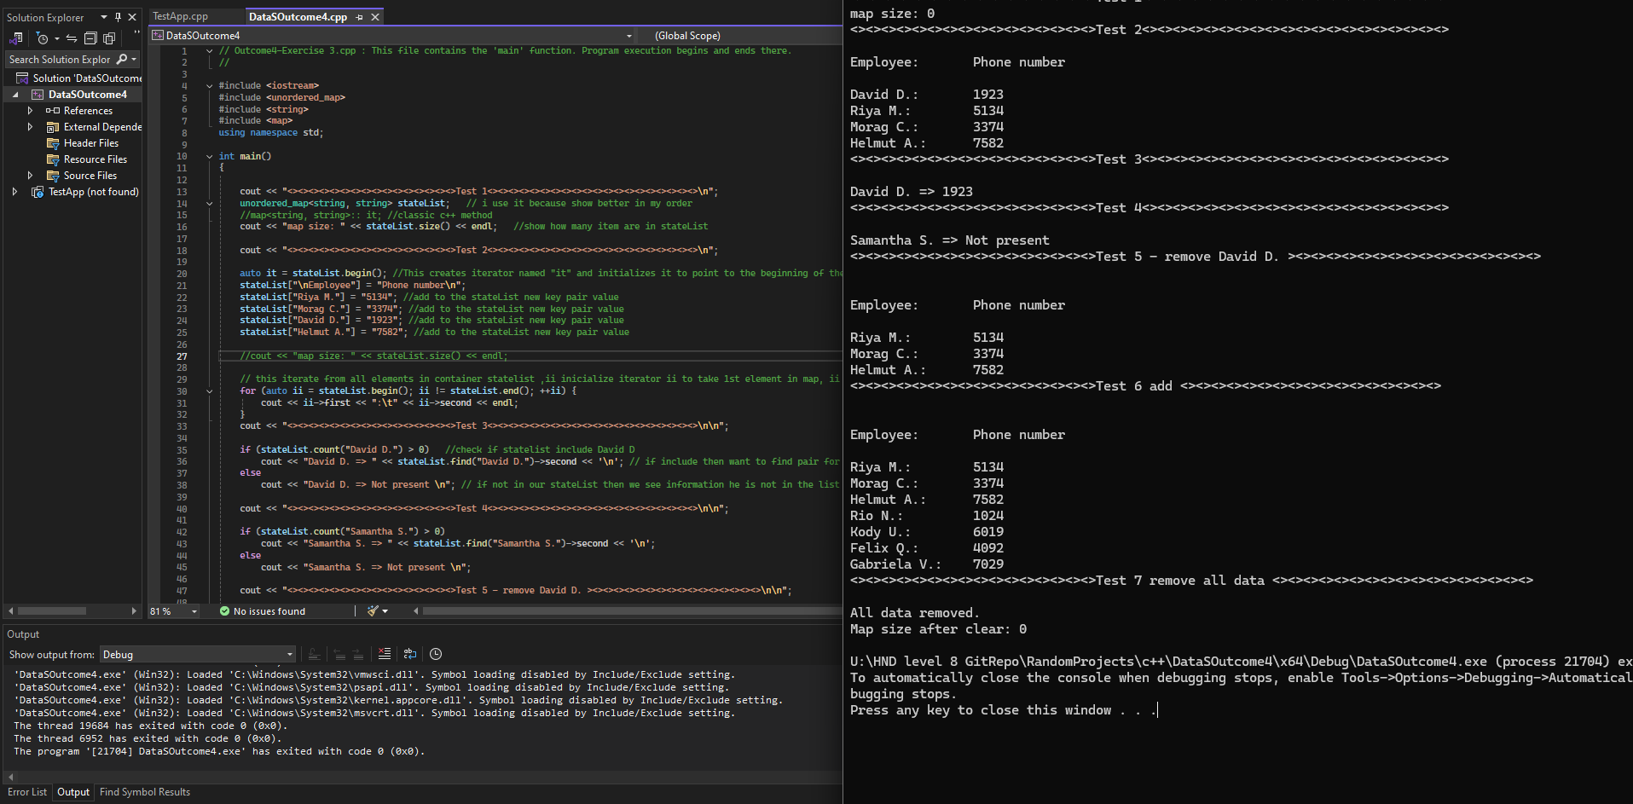Screen how program works: